1. Download and install [Jenkins](http://jenkins-ci.org/).
2. After the installation, you should be able to visit the Jenkins home page by visiting <http://localhost:8080/>.
3. Download the [Ant](https://ant.apache.org/bindownload.cgi) and extract the folder into local machine (ex: C:\Program Files).
4. Add the **ANT_HOME** in environment variables, ex: C:\Program Files\apache-ant-1.9.4\ and also provide **C:\Program Files\apache-ant-1.9.4\bin** in environment variable of **path**.
5. Configure Jenkins by clicking **Manage Jenkins** on the left sidebar and the go to the **Configure System** page.
6. Setup at least one **JDK installation** and one **Ant installation** as well.

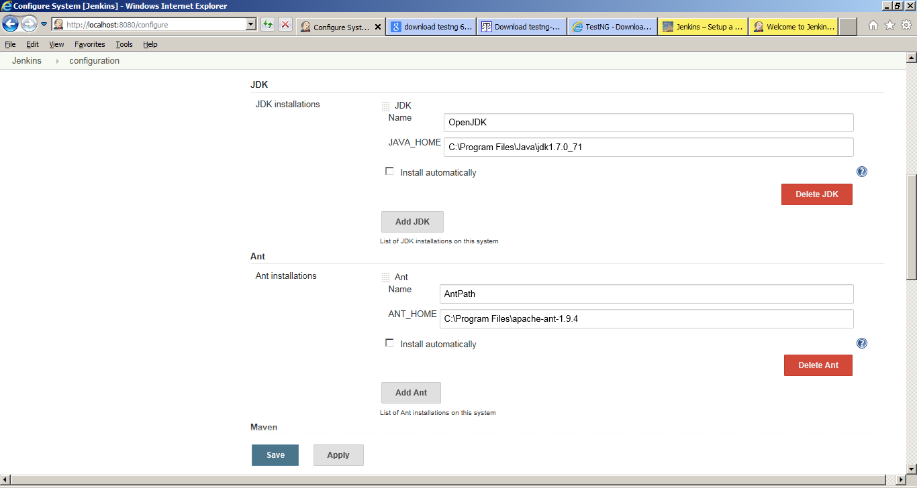  
[jenkins-simple-ant-build-project-3](http://eureka.ykyuen.info/?attachment_id=14679)

1. Now add a new job and call it **CRAFTCI**, select **Build a free-style software project**.  
   [jenkins-simple-ant-build-project-4](http://eureka.ykyuen.info/?attachment_id=14680)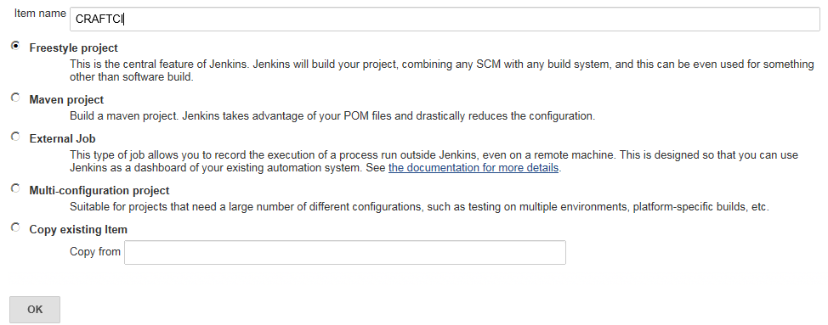
2. After the job is created, you will be on the job configuration page.
3. Add a new **Build step** and select **Invoke Ant**.  
   [jenkins-simple-ant-build-project-6](http://eureka.ykyuen.info/?attachment_id=14682)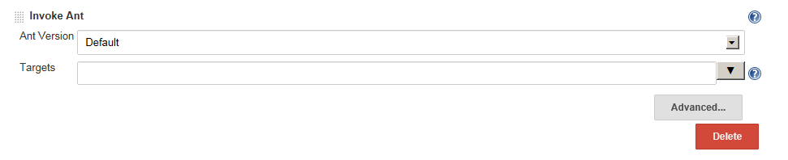
4. Select the Ant version which we have already configured it on the Configure System page. We could leave the target blank so it will run the default main target defined in the build.xml.